File 32_marea_base_year_dvmt.csv
April 15, 2026
Definition of the Input File
This is an optional file. VisionEval (https://visioneval.github.io/docs/model-inputs.html) explains that this file contains the base-year DVMT (Daily Vehicle Miles Traveled). If the user wants to use the default values, the data should be set to NA. Otherwise, the user can enter specific values. This file contains two attributes:
- UrbanLdvDvmt: Average daily vehicle miles of travel on roadways in the urbanized portion of the Marea by light-duty vehicles during the base year
- UrbanHvyTrkDvmt: Average daily vehicle miles of travel on roadways in the urbanized portion of the Marea by heavy trucks during the base year
For example, the data below suggest that base-year DVMT for light-duty vehicles and heavy trucks in Albemarle County is greater than that in the City of Charlottesville. Additionally, DVMT for light-duty vehicles is much greater than that for heavy trucks in both geographies.
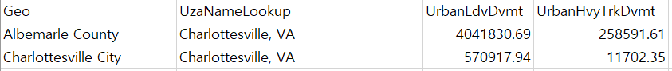
Possible Scenario
The document Task 7.2 Simplified Scenario Development guide, available at A Playbook for Simplified Approaches for Creating Scenarios in VisionEval, does not explicitly reference this file. In general one would expect changes in DVMT to yield changes in congestion, travel speeds, energy use, and emissions. However, VisionEval does not start with DVMT—rather, it starts with the drivers of travel demand (e.g., population, employment, and so forth) and then uses thse to obtain DVMT.
However, it is possible to use marea_base_year_dvmt for another reason—to understand the sensitivity of the results. For example, suppose a user wanted to evaluate how an increase in population and the number of households could increase total fuel consumption. A user would normally generate two model runs, where one might let marea_base_year_dvmt simply have “NA” values.
- Model run with base 2045 values for azone_hh_pop_by_age and bzone_dwelling_units
- Model run where the above two files were changed by 10% (or some other value)
From these two runs, the user could examine the change in DVMT and emissions. For example, one might find that DVMT increases by 12%.
The user might then do two more runs identical to those bulleted above but where marea_base_year_dvmt has not “NA” but rather the values given in this file. One could then see how changing assumptions about what your base year DVMT is changes the “12%” noted above. In this way, adjustments to marea_base_year_dvmt allow one to determine a confidence interval, of sorts, for certain scenarios.
Method Used for Virginia
To be clear, the user can elect to simply put “NA” in the lieu of the numbers shown such that one uses a file such as that shown below.
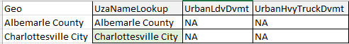
However, to have Virginia specific values, the following approach was undertaken.
Base Year
To obtain UZA Names for Virginia, FY-2025-2020-Census-UZA-Population-Data-01-16-2025.xlsx from the Federal Transit Administration was used. The newest dataset is released in 2025, but it was assumed that the UZA names for 2025 are the same as those in 2024.
To match the Marea geography used in the model, UZA names were mapped as follows:
Geo | UzaNameLookup | Geo | UzaNameLookup
Accomack County |  | Lancaster County
Albemarle County | Charlottesville, VA | Lee County
Alexandria City | Washington-Arlington, DC-VA-MD | Lexington City
Alleghany County |  | Loudoun County | Washington-Arlington, DC-VA-MD
Amelia County |  | Louisa County
Amherst County |  | Lunenburg County
Appomattox County |  | Lynchburg City | Lynchburg, VA
Arlington County | Washington-Arlington, DC-VA-MD | Madison County
Augusta County | Staunton-Waynesboro, VA | Manassas City | Washington-Arlington, DC-VA-MD
Bath County |  | Manassas Park City | Washington-Arlington, DC-VA-MD
Bedford County |  | Martinsville City
Bland County |  | Mathews County
Botetourt County |  | Mecklenburg County
Bristol City | Bristol, TN-VA | Middlesex County
Brunswick County |  | Montgomery County | Blacksburg-Christiansburg, VA
Buchanan County |  | Nelson County
Buckingham County |  | New Kent County
Buena Vista City |  | Newport News City | Virginia Beach-Norfolk, VA
Campbell County |  | Norfolk City | Virginia Beach-Norfolk, VA
Caroline County |  | Northampton County
Carroll County |  | Northumberland County
Charles City County |  | Norton City
Charlotte County |  | Nottoway County
Charlottesville City | Charlottesville, VA | Orange County
Chesapeake City | Virginia Beach-Norfolk, VA | Page County
Chesterfield County |  | Patrick County
Clarke County |  | Petersburg City
Colonial Heights City |  | Pittsylvania County
Covington City |  | Poquoson City | Virginia Beach-Norfolk, VA
Craig County |  | Portsmouth City | Virginia Beach-Norfolk, VA
Culpeper County |  | Powhatan County
Cumberland County |  | Prince Edward County
Danville City |  | Prince George County
Dickenson County |  | Prince William County | Washington-Arlington, DC-VA-MD
Dinwiddie County |  | Pulaski County
Emporia City |  | Radford City
Essex County |  | Rappahannock County
Fairfax City | Washington-Arlington, DC-VA-MD | Richmond City | Richmond, VA
Fairfax County | Washington-Arlington, DC-VA-MD | Richmond County
Falls Church City | Washington-Arlington, DC-VA-MD | Roanoke City | Roanoke, VA
Fauquier County |  | Roanoke County | Roanoke, VA
Floyd County |  | Rockbridge County
Fluvanna County |  | Rockingham County
Franklin City |  | Russell County
Franklin County |  | Salem City | Roanoke, VA
Frederick County |  | Scott County
Fredericksburg City | Fredericksburg, VA | Shenandoah County
Galax City |  | Smyth County
Giles County |  | Southampton County
Gloucester County |  | Spotsylvania County | Fredericksburg, VA
Goochland County |  | Stafford County | Fredericksburg, VA
Grayson County |  | Staunton City | Staunton-Waynesboro, VA
Greene County |  | Suffolk City | Virginia Beach-Norfolk, VA
Greensville County |  | Surry County
Halifax County |  | Sussex County
Hampton City |  | Tazewell County
Hanover County |  | Virginia Beach City | Virginia Beach-Norfolk, VA
Harrisonburg City | Harrisonburg, VA | Warren County
Henrico County |  | Washington County
Henry County |  | Waynesboro City | Staunton-Waynesboro, VA
Highland County |  | Westmoreland County
Hopewell City |  | Williamsburg City | Williamsburg, VA
Isle of Wight County | Virginia Beach-Norfolk, VA | Winchester City | Winchester, VA
James City County | Williamsburg, VA | Wise County
King and Queen County |  | Wythe County
King George County |  | York County
King William County

To obtain DVMT, 2022 Report 1226 VMT from the Virginia Open Data Portal was used. As 2022 data is the newest set available, base year (2024) data was projected based on the latest three years’ trend.
The data set from the Data Portal does not provide the same categories as the CSV file, the mapping of federal vehicle classes to the VisionEval model categories is required. The following table presents the result.
Federal Vehicle Class |  | VisionEval
01 | Motorcycles | Excluded
02 | Passenger Cars | Ldv
03 | Two Axle, 4 Tire Single Unit Vehicles | Ldv
04 | Buses | Excluded
05 | Two Axle, 6 Tire Single Unit Trucks | HvyTrk
06 | Three Axle Single Unit Trucks | HvyTrk
07 | Four or More Axle Single Unit Trucks | HvyTrk
08 | Four Axle or Fewer Single Trailers | HvyTrk
09 | Five Axle Single Trailers | HvyTrk
10 | Six or More Axle Single Trailers | HvyTrk
11 | Five Axle or Fewer Multi-Trailers | HvyTrk
12 | Six Axle Multi-Trailers | HvyTrk
13 | Seven or More Axle Multi-Trailers | HvyTrk

To calculate DVMT by jurisdiction, and vehicle class, the SUMIFS function was used in Excel. (The original dataset was cleaned and reformatted for clarity, and the SUMIFS function was used to perform the aggregation.)
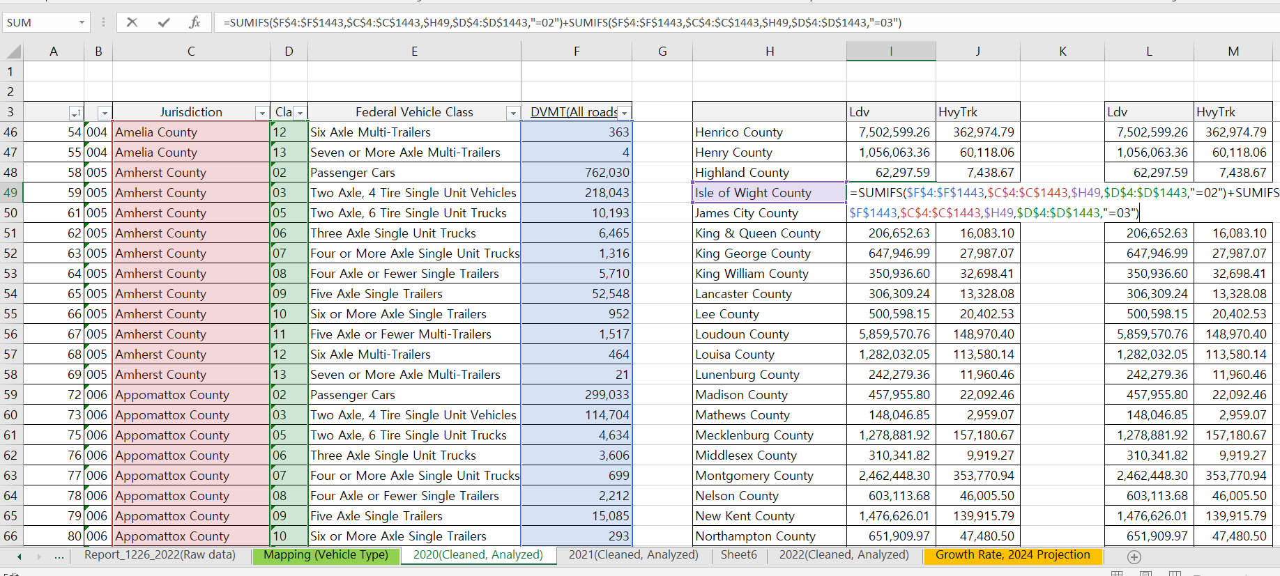
The 2024 value was projected by calculating the compound annual growth rate (CAGR) based on three years of historical data (2020–2022). However, due to the presence of abnormally large values in some cases, the smallest value among the following three growth rates was selected as the optimal value: the 2020–2021 growth rate, the 2021–2022 growth rate, and the overall 2020–2022 CAGR.
To ensure consistency in the geography used for VisionEval inputs, the following standard was established based on the azone geography.
Number | Name | Number | Name | Number | Name
1 | Accomack County | 51 | Goochland County | 101 | Prince William County
2 | Albemarle County | 52 | Grayson County | 102 | Pulaski County
3 | Alexandria City | 53 | Greene County | 103 | Radford City
4 | Alleghany County | 54 | Greensville County | 104 | Rappahannock County
5 | Amelia County | 55 | Halifax County | 105 | Richmond City
6 | Amherst County | 56 | Hampton City | 106 | Richmond County
7 | Appomattox County | 57 | Hanover County | 107 | Roanoke City
8 | Arlington County | 58 | Harrisonburg City | 108 | Roanoke County
9 | Augusta County | 59 | Henrico County | 109 | Rockbridge County
10 | Bath County | 60 | Henry County | 110 | Rockingham County
11 | Bedford County | 61 | Highland County | 111 | Russell County
12 | Bland County | 62 | Hopewell City | 112 | Salem City
13 | Botetourt County | 63 | Isle of Wight County | 113 | Scott County
14 | Bristol City | 64 | James City County | 114 | Shenandoah County
15 | Brunswick County | 65 | King and Queen County | 115 | Smyth County
16 | Buchanan County | 66 | King George County | 116 | Southampton County
17 | Buckingham County | 67 | King William County | 117 | Spotsylvania County
18 | Buena Vista City | 68 | Lancaster County | 118 | Stafford County
19 | Campbell County | 69 | Lee County | 119 | Staunton City
20 | Caroline County | 70 | Lexington City | 120 | Suffolk City
21 | Carroll County | 71 | Loudoun County | 121 | Surry County
22 | Charles City County | 72 | Louisa County | 122 | Sussex County
23 | Charlotte County | 73 | Lunenburg County | 123 | Tazewell County
24 | Charlottesville City | 74 | Lynchburg City | 124 | Virginia Beach City
25 | Chesapeake City | 75 | Madison County | 125 | Warren County
26 | Chesterfield County | 76 | Manassas City | 126 | Washington County
27 | Clarke County | 77 | Manassas Park City | 127 | Waynesboro City
28 | Colonial Heights City | 78 | Martinsville City | 128 | Westmoreland County
29 | Covington City | 79 | Mathews County | 129 | Williamsburg City
30 | Craig County | 80 | Mecklenburg County | 130 | Winchester City
31 | Culpeper County | 81 | Middlesex County | 131 | Wise County
32 | Cumberland County | 82 | Montgomery County | 132 | Wythe County
33 | Danville City | 83 | Nelson County | 133 | York County
34 | Dickenson County | 84 | New Kent County
35 | Dinwiddie County | 85 | Newport News City
36 | Emporia City | 86 | Norfolk City
37 | Essex County | 87 | Northampton County
38 | Fairfax City | 88 | Northumberland County
39 | Fairfax County | 89 | Norton City
40 | Falls Church City | 90 | Nottoway County
41 | Fauquier County | 91 | Orange County
42 | Floyd County | 92 | Page County
43 | Fluvanna County | 93 | Patrick County
44 | Franklin City | 94 | Petersburg City
45 | Franklin County | 95 | Pittsylvania County
46 | Frederick County | 96 | Poquoson City
47 | Fredericksburg City | 97 | Portsmouth City
48 | Galax City | 98 | Powhatan County
49 | Giles County | 99 | Prince Edward County
50 | Gloucester County | 100 | Prince George County

Forecast Year
This input file does not require the data for forecast year.

Appendix
https://www.transit.dot.gov/funding/apportionments/census-urbanized-area-population-and-population-density-data-used-section?utm_source=chatgpt.com
(Location on the wepsite: Funding–Resources–Apportionments–Related Links (Formula Apportionments Data) –Census Urbanized Area Population and Population Density Data)
URL: https://data.virginia.gov/dataset/2022-report-1226-vmt-by-physical-jurisdiction-by-federal-vehicle-class-towns-rolled-into-counties
(Location on the website: Organizations–Department of Transportation)

